Jose Marquez

Course: Intro to Computer Graphics

Assignment 3

Part 1 - Drawing the Cube

For part 1, I implemented a Cube class that encapsulates the data and behavior of a 3D cube. The class includes:

- Geometry (vertices):
I defined 8 vertices for a unit cube centered at the origin, with coordinates in the range [-0.5, 0.5] in x,y, and z to keep the cube centered for later transformations.

- Faces/Triangles:
I created an of 12 triangular faces. Each face of the cube is split into 2 triangles, and each triangle indexes into the vertex array. This matches the specification of separating geometry and topology.

- Helper to Flatten data:
Inside the class, I wrote a helper method to convert the vertex and face arrays into a flat Float32Array of positions.

• WebGL buffer creation:
The class has a private method _createPositionBuffer() that:
• Builds the flattened position array.
• Creates an ARRAY_BUFFER in WebGL.
• Uploads the data to the GPU.
• Stores numVertices for use in draw calls.
• Draw method:
The draw(positionAttribLocation) method:
• Binds the buffer,
• Enables the vertex attribute,
• Sets up the vertexAttribPointer,
• Calls gl.drawArrays(gl.TRIANGLES, 0, numVertices) to render the cube.

Part 2 - Modeling

For Part 2, I created the following functions:

- DrawTetrahedron
- DrawCibe
- DrawOctahedron
- DrawDodecahedron
- DrawIcosahedron
- DrawSphere

To avoid repeating code, I implemented a general helper:

• createAndDrawFromGeometry(gl, positionAttribLocation, vertices, faces)
This function:
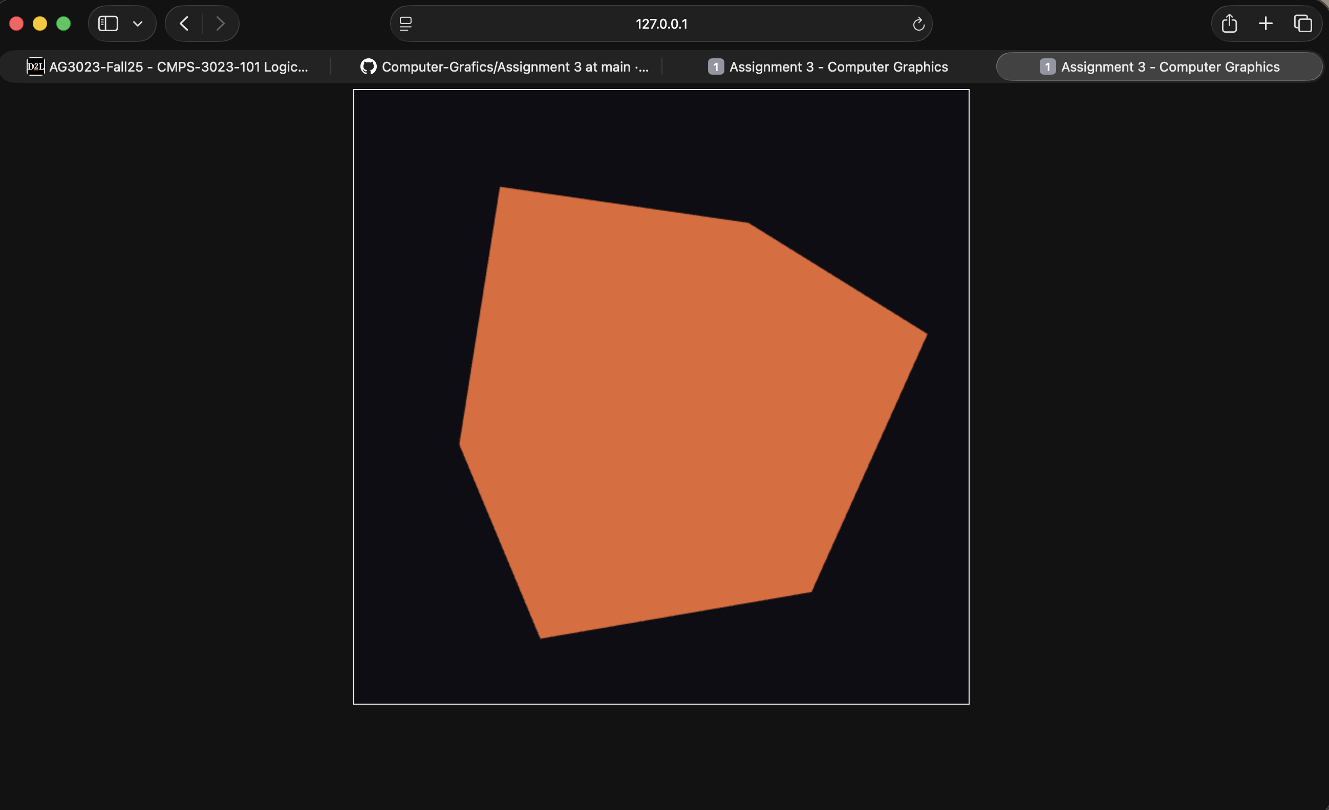
• Flattens the given geometry and faces into a Float32Array,
• Creates a WebGL buffer,
• Sets the attribute pointer,
• Draws the triangles with gl.drawArrays(gl.TRIANGLES, …).

Each of the Part 2 functions then does the following:
• DrawCube(gl, positionAttribLocation)
Uses the Cube class from Part 1:
• Creates a Cube object.
• Calls its draw method.

• DrawTetrahedron(gl, positionAttribLocation)
Defines 4 vertices forming a regular tetrahedron (using four corners of a cube scaled to ±0.5) and 4 triangular faces. Uses createAndDrawFromGeometry to draw it.

•DrawOctahedron(gl, positionAttribLocation)
Uses 6 vertices on the coordinate axes (±X, ±Y, ±Z), scaled to 0.5, and 8 triangular faces that form a regular octahedron.

• DrawIcosahedron(gl, positionAttribLocation)
Uses the golden ratio (φ) to define 12 standard icosahedron vertices, normalizes them to approximately radius 0.5, and defines the 20 triangular faces of a regular icosahedron.

• DrawDodecahedron(gl, positionAttribLocation)
Defines 20 vertices (including cube corners and points using φ and 1/φ), normalizes them to fit within a radius of about 0.5, and then:
• Specifies 12 pentagonal faces.
• Triangulates each pentagon into 3 triangles using a fan pattern.
This produces the faces of a regular dodecahedron.

• DrawSphere(gl, positionAttribLocation)
Implements a latitude–longitude style sphere:
• Generates vertices using θ (latitude) and φ (longitude) loops on a sphere of radius 0.5.
• Connects them into a grid of quads.
• Splits each quad into 2 triangles (so the sphere is drawn as many small triangles).
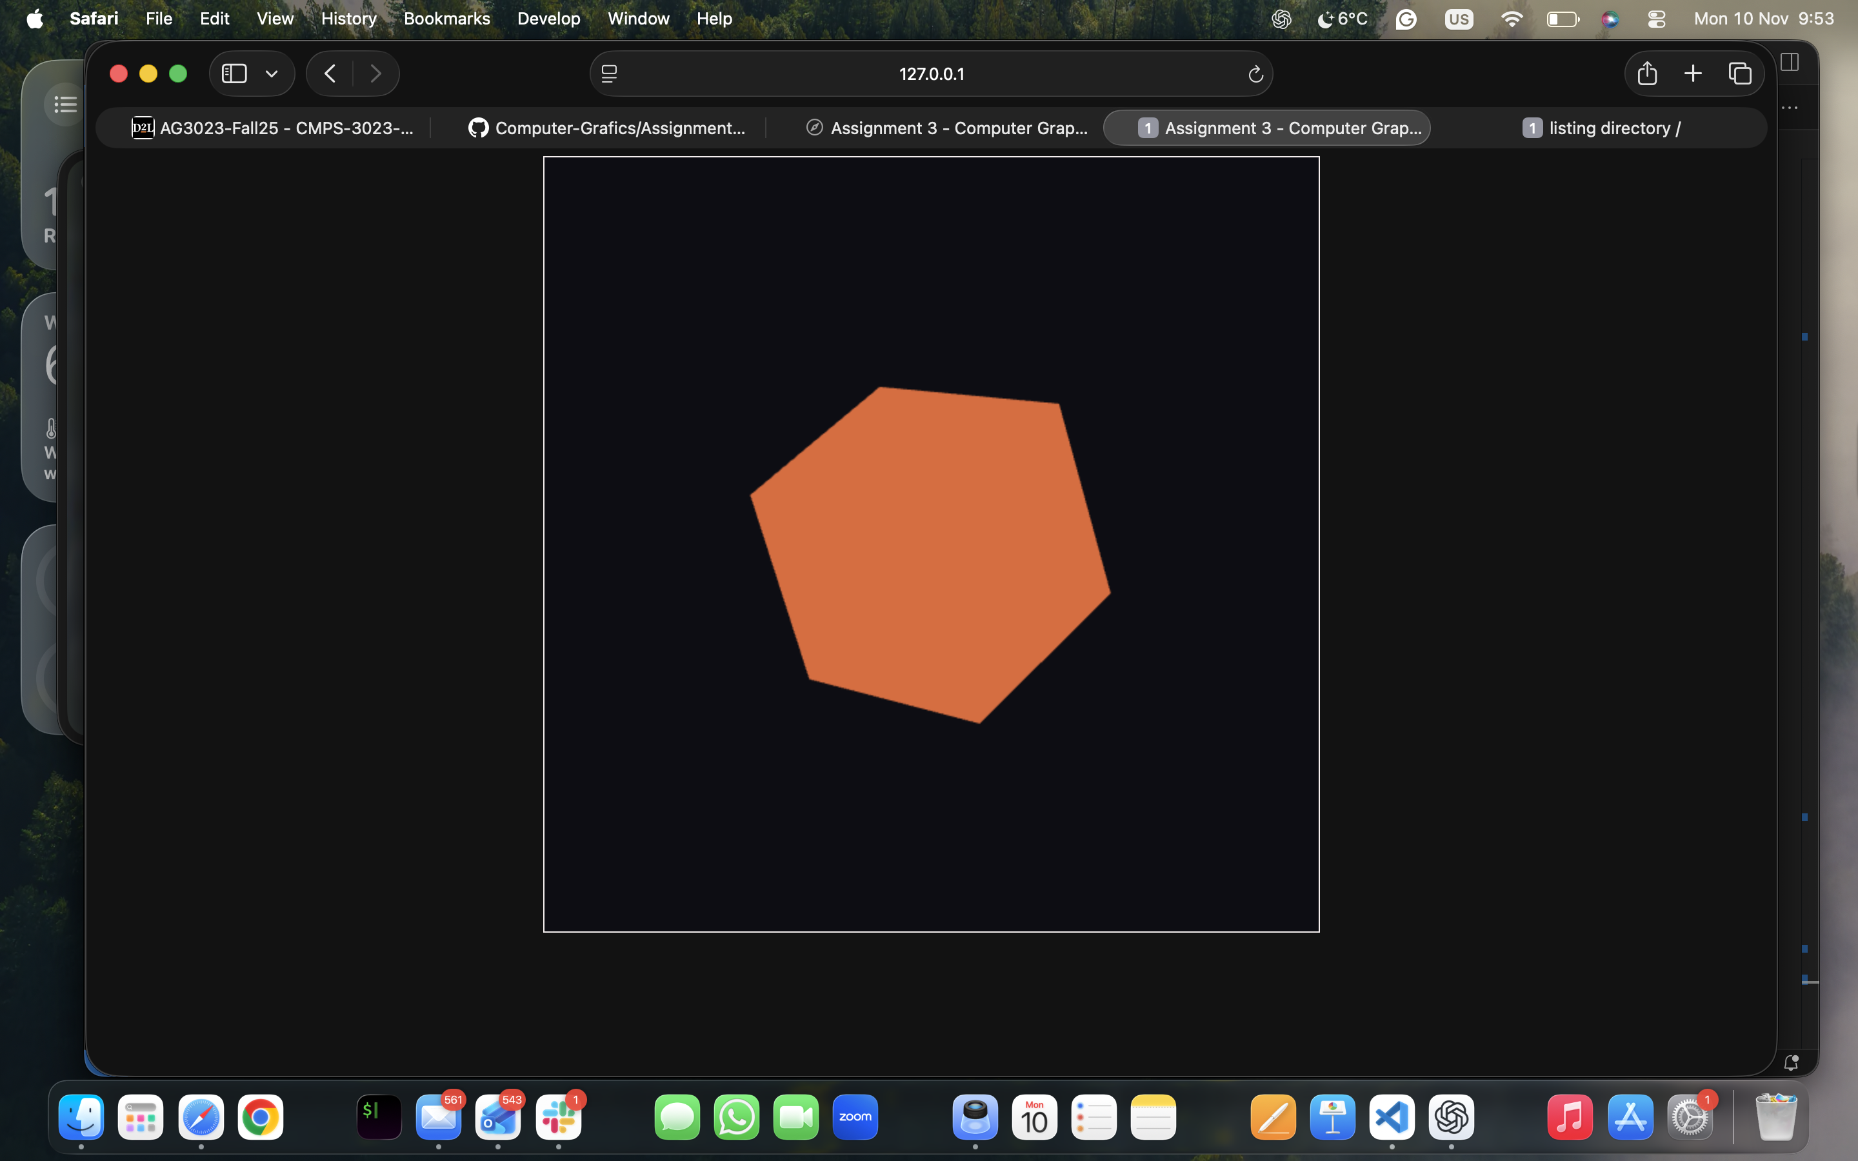
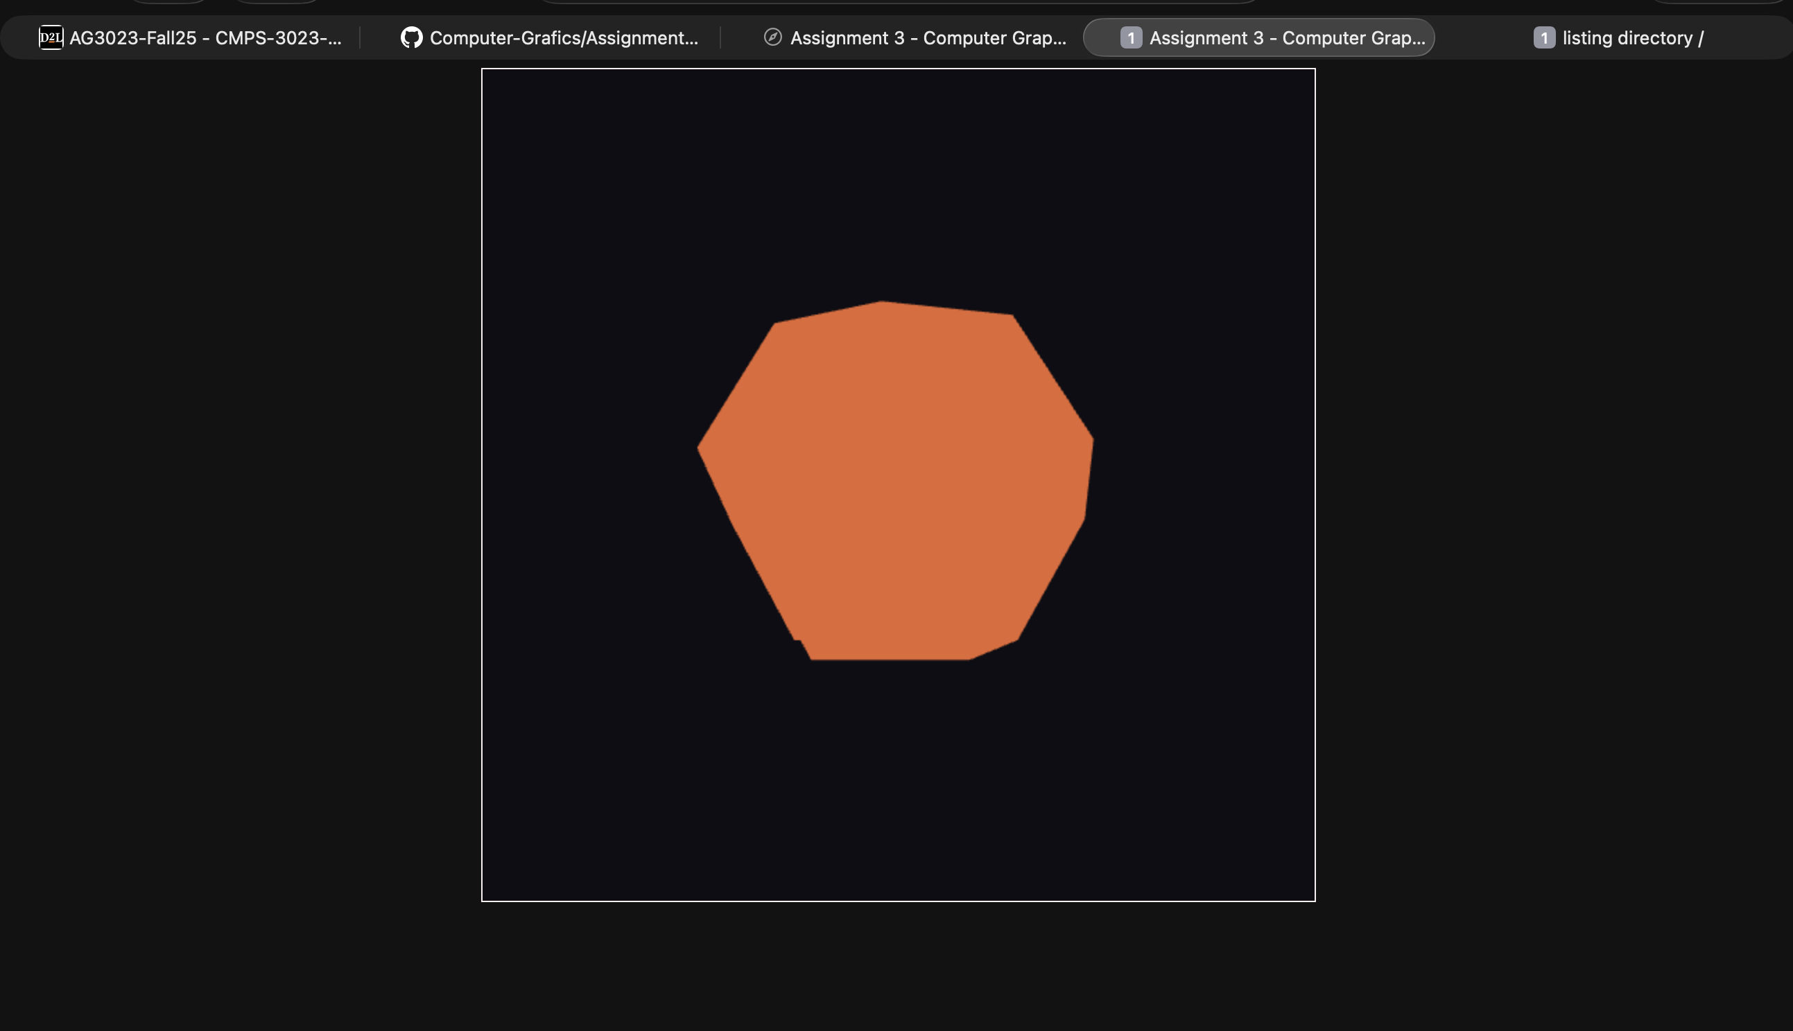
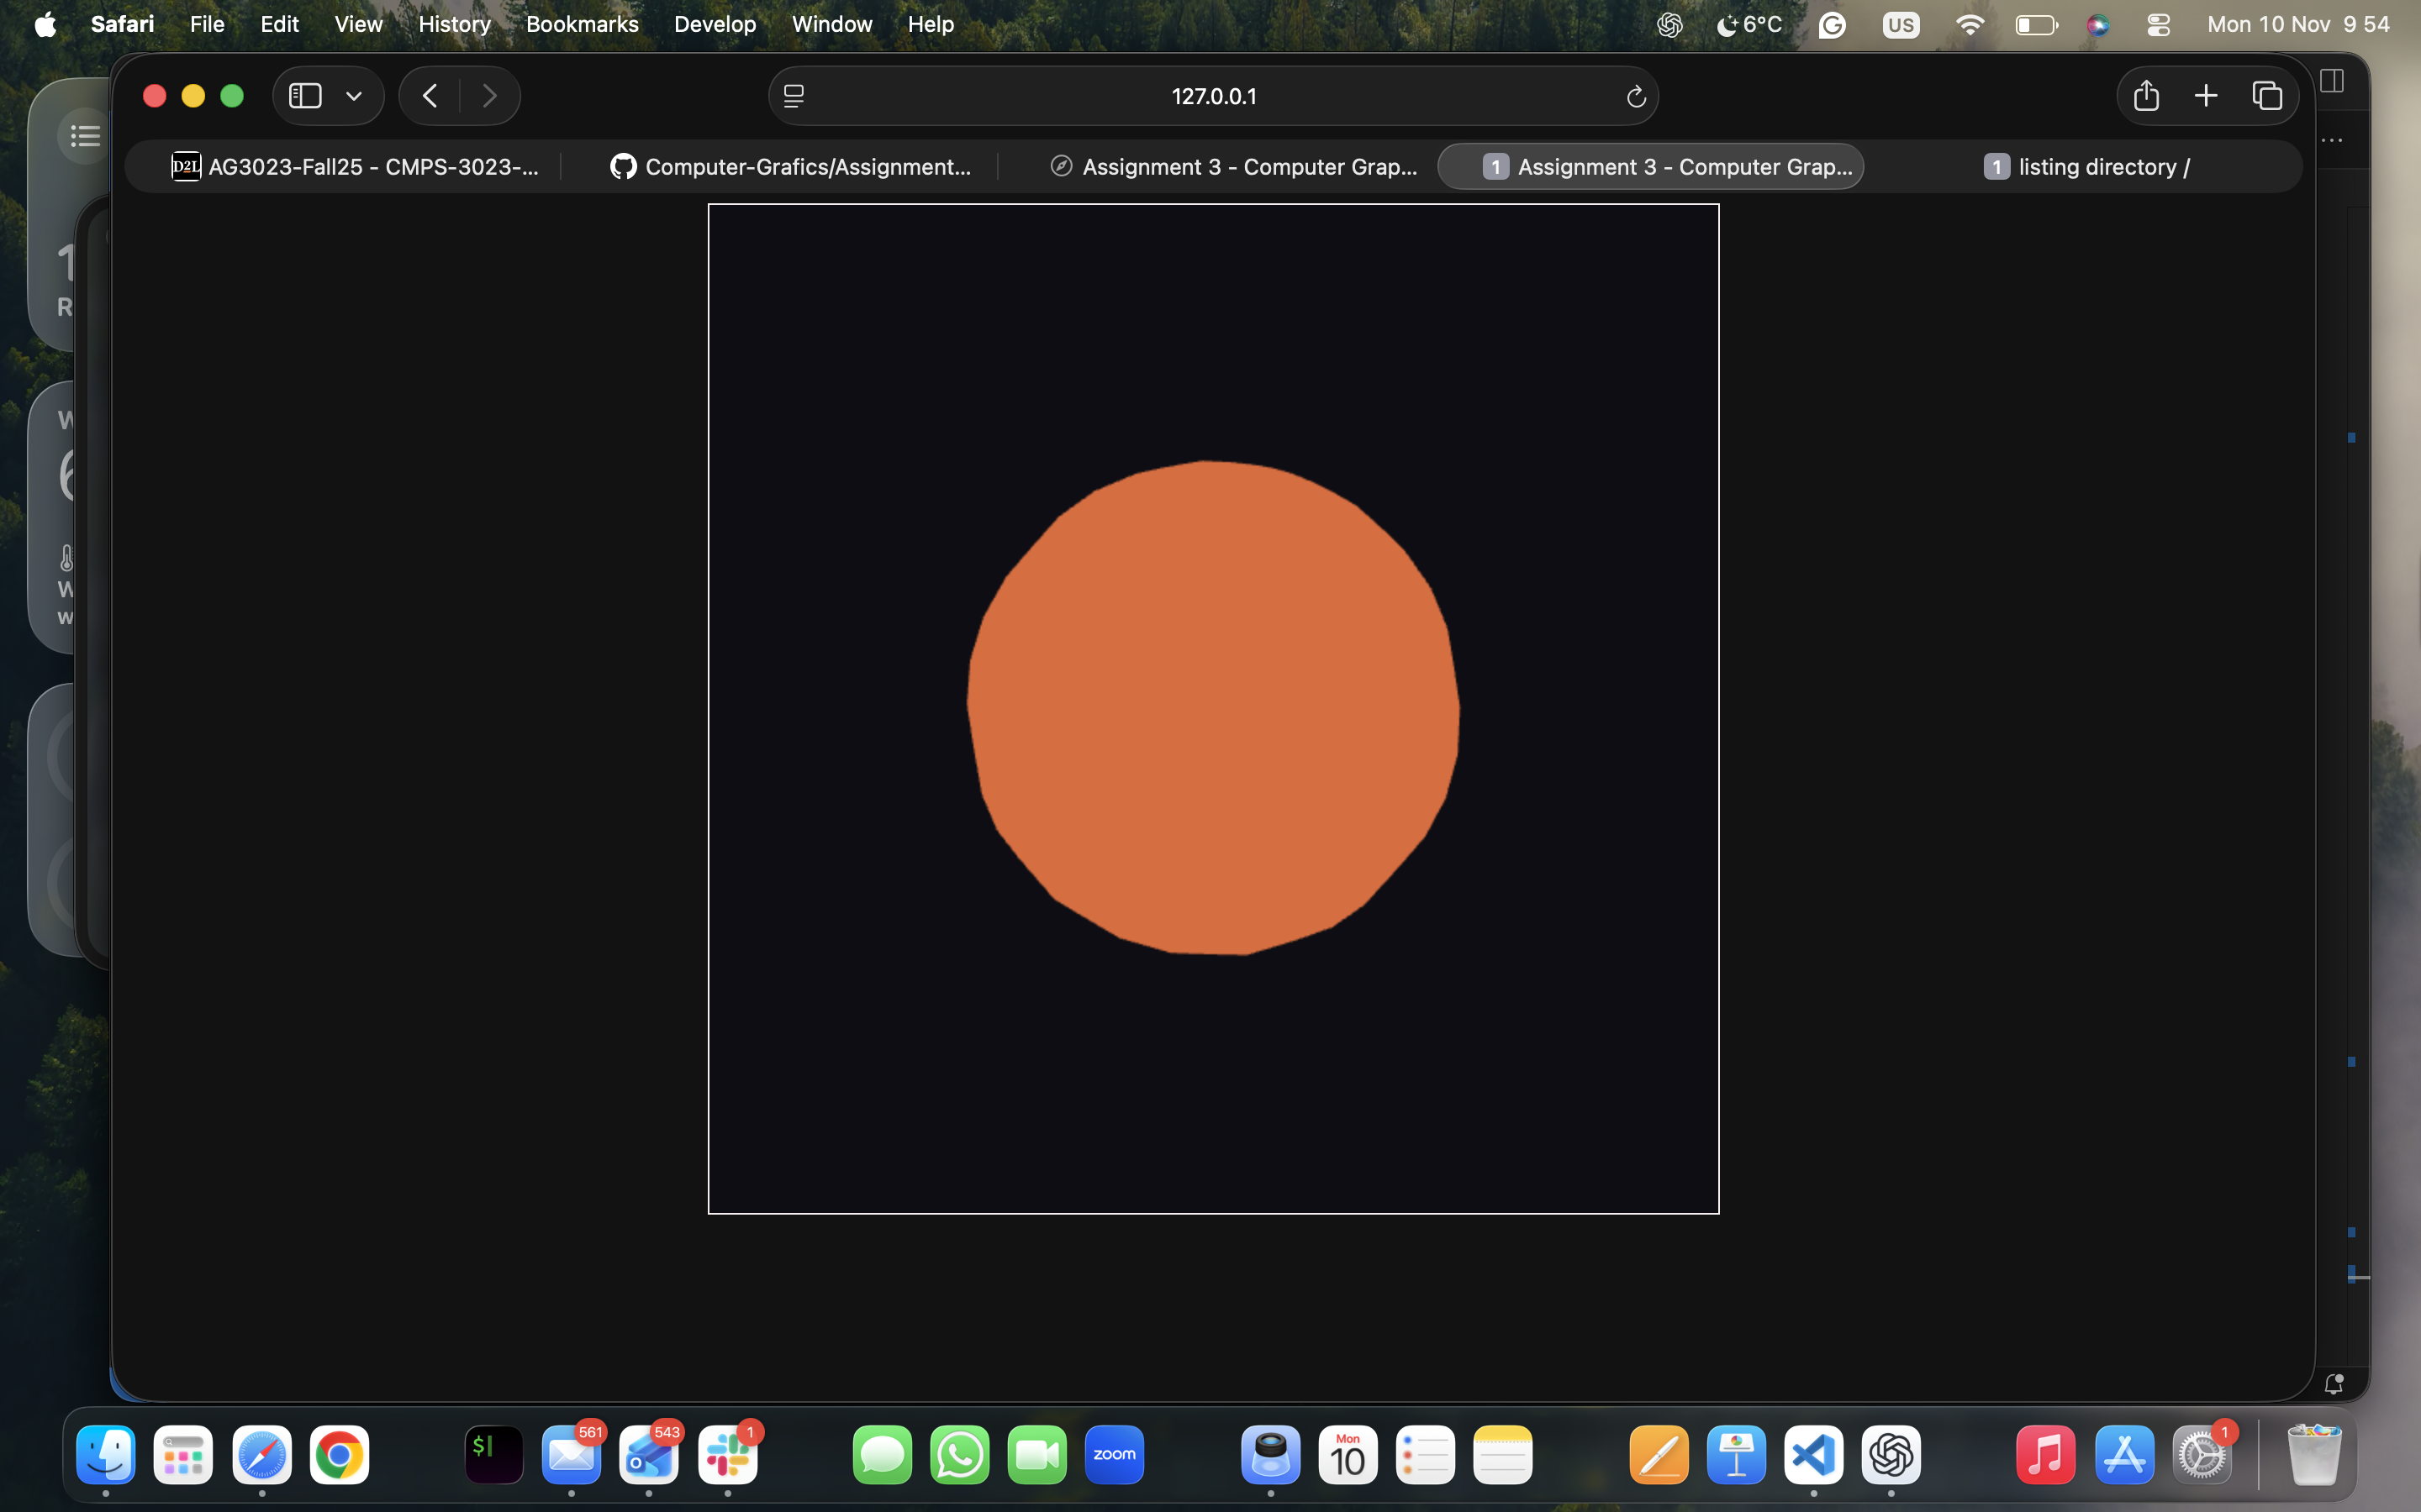
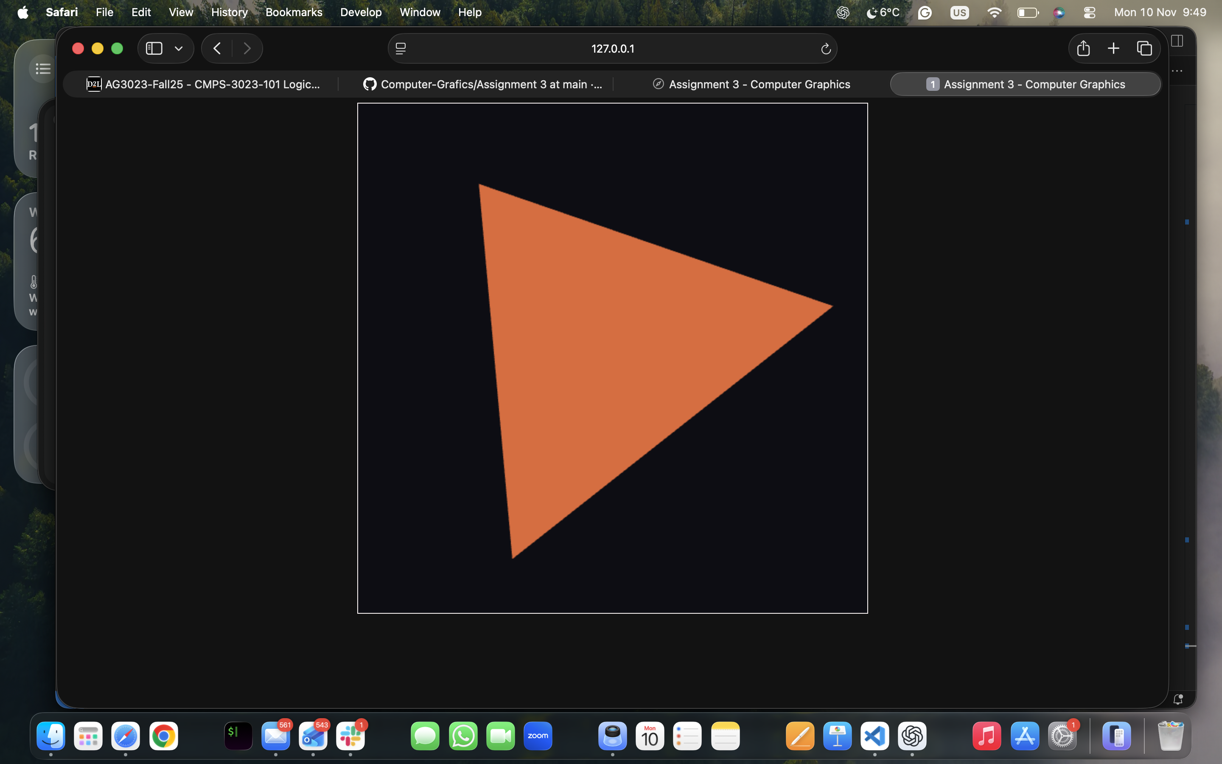

Part 3 - Creating a 3D scene

For part 3, I created a complete 3D scene using:

- Projection matrix:
I used a perspective projection with a 45-degree field of view, the current canvas aspect ratio, and near/far planes (0.1, 50).

2. View matrix:
I implemented a makeLookAt(eye, target, up) function that builds a camera matrix.
The camera is placed at eye = [ 4, 3, 6], looking at [ 0, 0, 0], with up = [ 0,1, 0].
This gives a nice angled view of the entire scene.

3. Model matrices and transforms
For each object, I used a combination of:

• makeScale(sx, sy, sz) for non-uniform scaling,

• makeRotationY(angle) for rotation around the Y-axis,

- makeTranslation(tx, ty, tz) to place objects in the scene.

4. Scene layout:
Using these transforms and the Part 2 draw functions, I created a small “world”:
- Ground plane:
A cube scaled to be wide and flat in XZ, acting as a ground/floor.

• Left building:
A tall, scaled cube positioned to the left, rotated slightly around the Y axis.

• Left roof:
A tetrahedron is placed on top of the left building to form a roof.

• Right building:
Another tall cube on the right side, also slightly rotated.

• Right roof:
A dodecahedron scaled down and placed on top of the right building like a decorative dome.

• Central object:
A sphere in the middle of the scene, representing a fountain or statue.

• Floating object:
A small icosahedron positioned above the scene, like a “floating crystal” or decorative element.

5. MVP pipeline:
For each object, I compute:
- model (using scale/rotate/translate),

- mvp = proj * view * model,

• Then upload MVP as a uniform mat4 u_MVP and call the appropriate DrawX function.

The result is a composed 3D scene that demonstrates all the solids from Part 2 and uses all three matrices (Model, View, Projection) as required.

Estimated Time Spent

It took me around a week, working an hour each day. This includes reading instructions, designing the geometry and topology for each solid, debugging (had a rough time with this), and building the final 3D scene.

Experience and Problems Encountered

While working on this assignment, I ran into several issues and learned a lot from debugging them:

• Script not running / blank canvas:
Initially, nothing appeared on the screen. I discovered issues such as a misspelled CSS selector (cnavas instead of canvas) and needed to confirm that my JavaScript file was correctly linked and loaded.

• Class method syntax errors:
When I first wrote the Cube class, I accidentally put plain JavaScript statements (like const gl = this.gl;) directly inside the class body without wrapping them in a method, which caused syntax errors. I learned that inside a class, all code must be inside methods, so I properly defined _createPositionBuffer() and other helpers.

•Tiny typos causing big problems:
At one point, I had an extra stray character at the end of a line (e.g., this.rotation = [0, 0, 0]; s), which caused JavaScript errors. This reminded me to check the console frequently and read error messages carefully.

• Understanding why I only saw an orange square:
Before adding the MVP matrix, I saw only a flat orange square. This made sense once I realized that I was drawing the cube with no perspective or camera and no rotation, so I was just looking straight at one face of the cube. Adding the view and projection matrices (and rotating the model) made the 3D nature visible.

• Keeping shapes centered and scaled properly:
When designing the Platonic solids and the sphere, I had to be careful about vertex positions and normalizing them so they stayed within a consistent size range (~0.5 radius). This made the scene composition easier and prevented shapes from being too
big or too small.

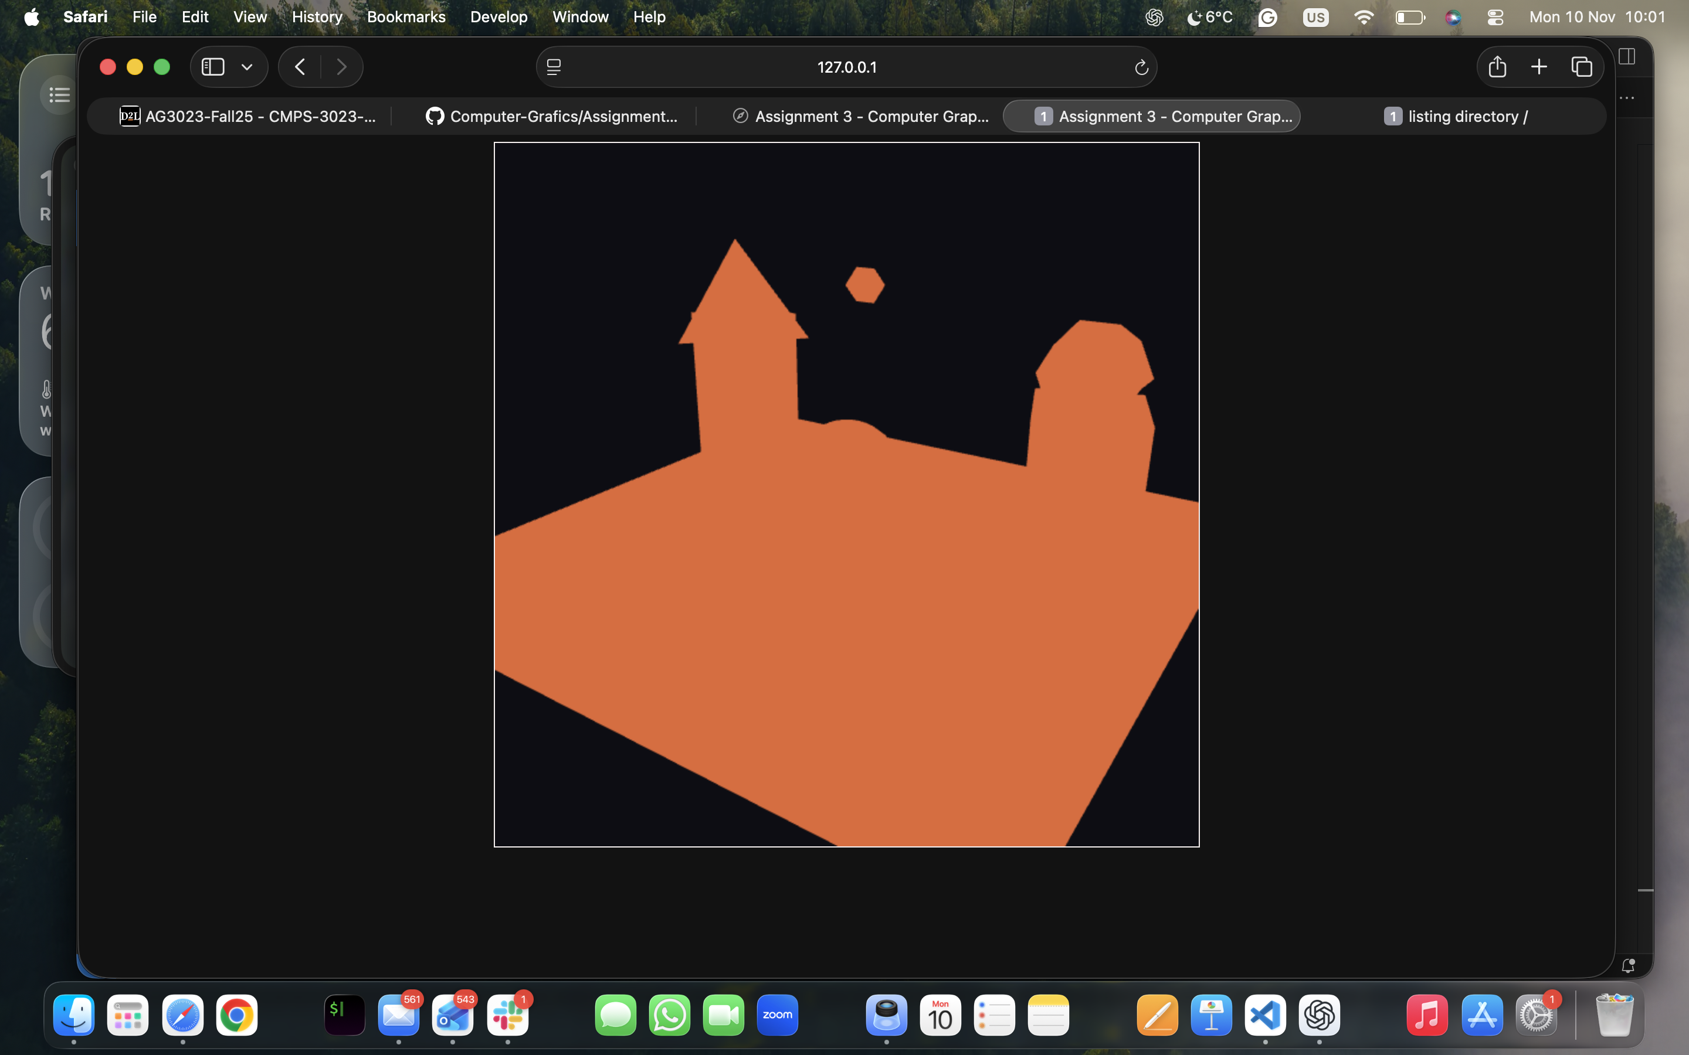

Extensions Added

I did not add major extensions for this assignment:

- Implemented a lookAt camera function instead of using a simple translation for the new matrix
- Create a more structured scene layout with multiple objects that visually show the different solids interacting with each other in one 3D scene

Possible future extensions:

- Simple animations
- Using different colors or basic lighting to distinguish shapes more easily.

5. Sources Used

- Course lecture notes and slides provided by the instructor.

- WebGL reference documentation and examples (for buffer setup and shader usage).

- Basic math resources for Platonic solids (vertex layouts and face indices).

- My own previous code from earlier assignments as a reference for matrix and buffer setup.

